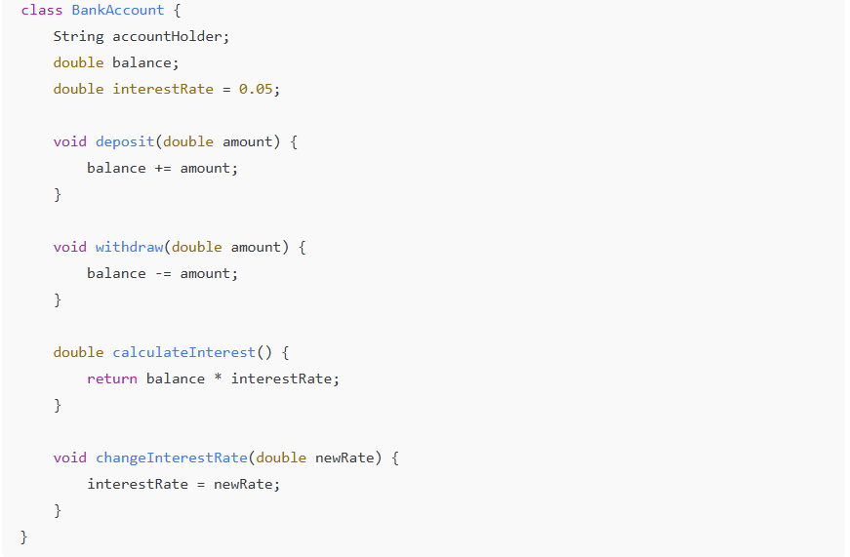
Questions
- Should accountHolder be static or non-static? Why?
- Should balance be static or non-static? Why?
- Should interestRate be static or non-static? Why?
- Should deposit() be static or non-static?
- Should changeInterestRate() be static or non-static?

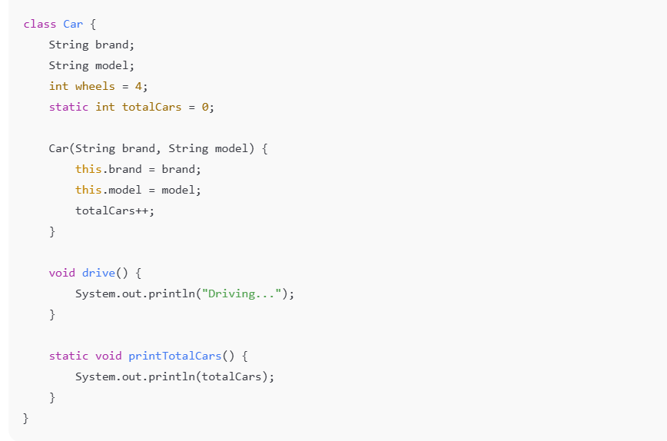

Questions
- Should brand be static?
- Should wheels be static?
- Why is totalCars static?
- Can printTotalCars() access brand directly?
- Why is drive() non-static?

